United Bank for Africa

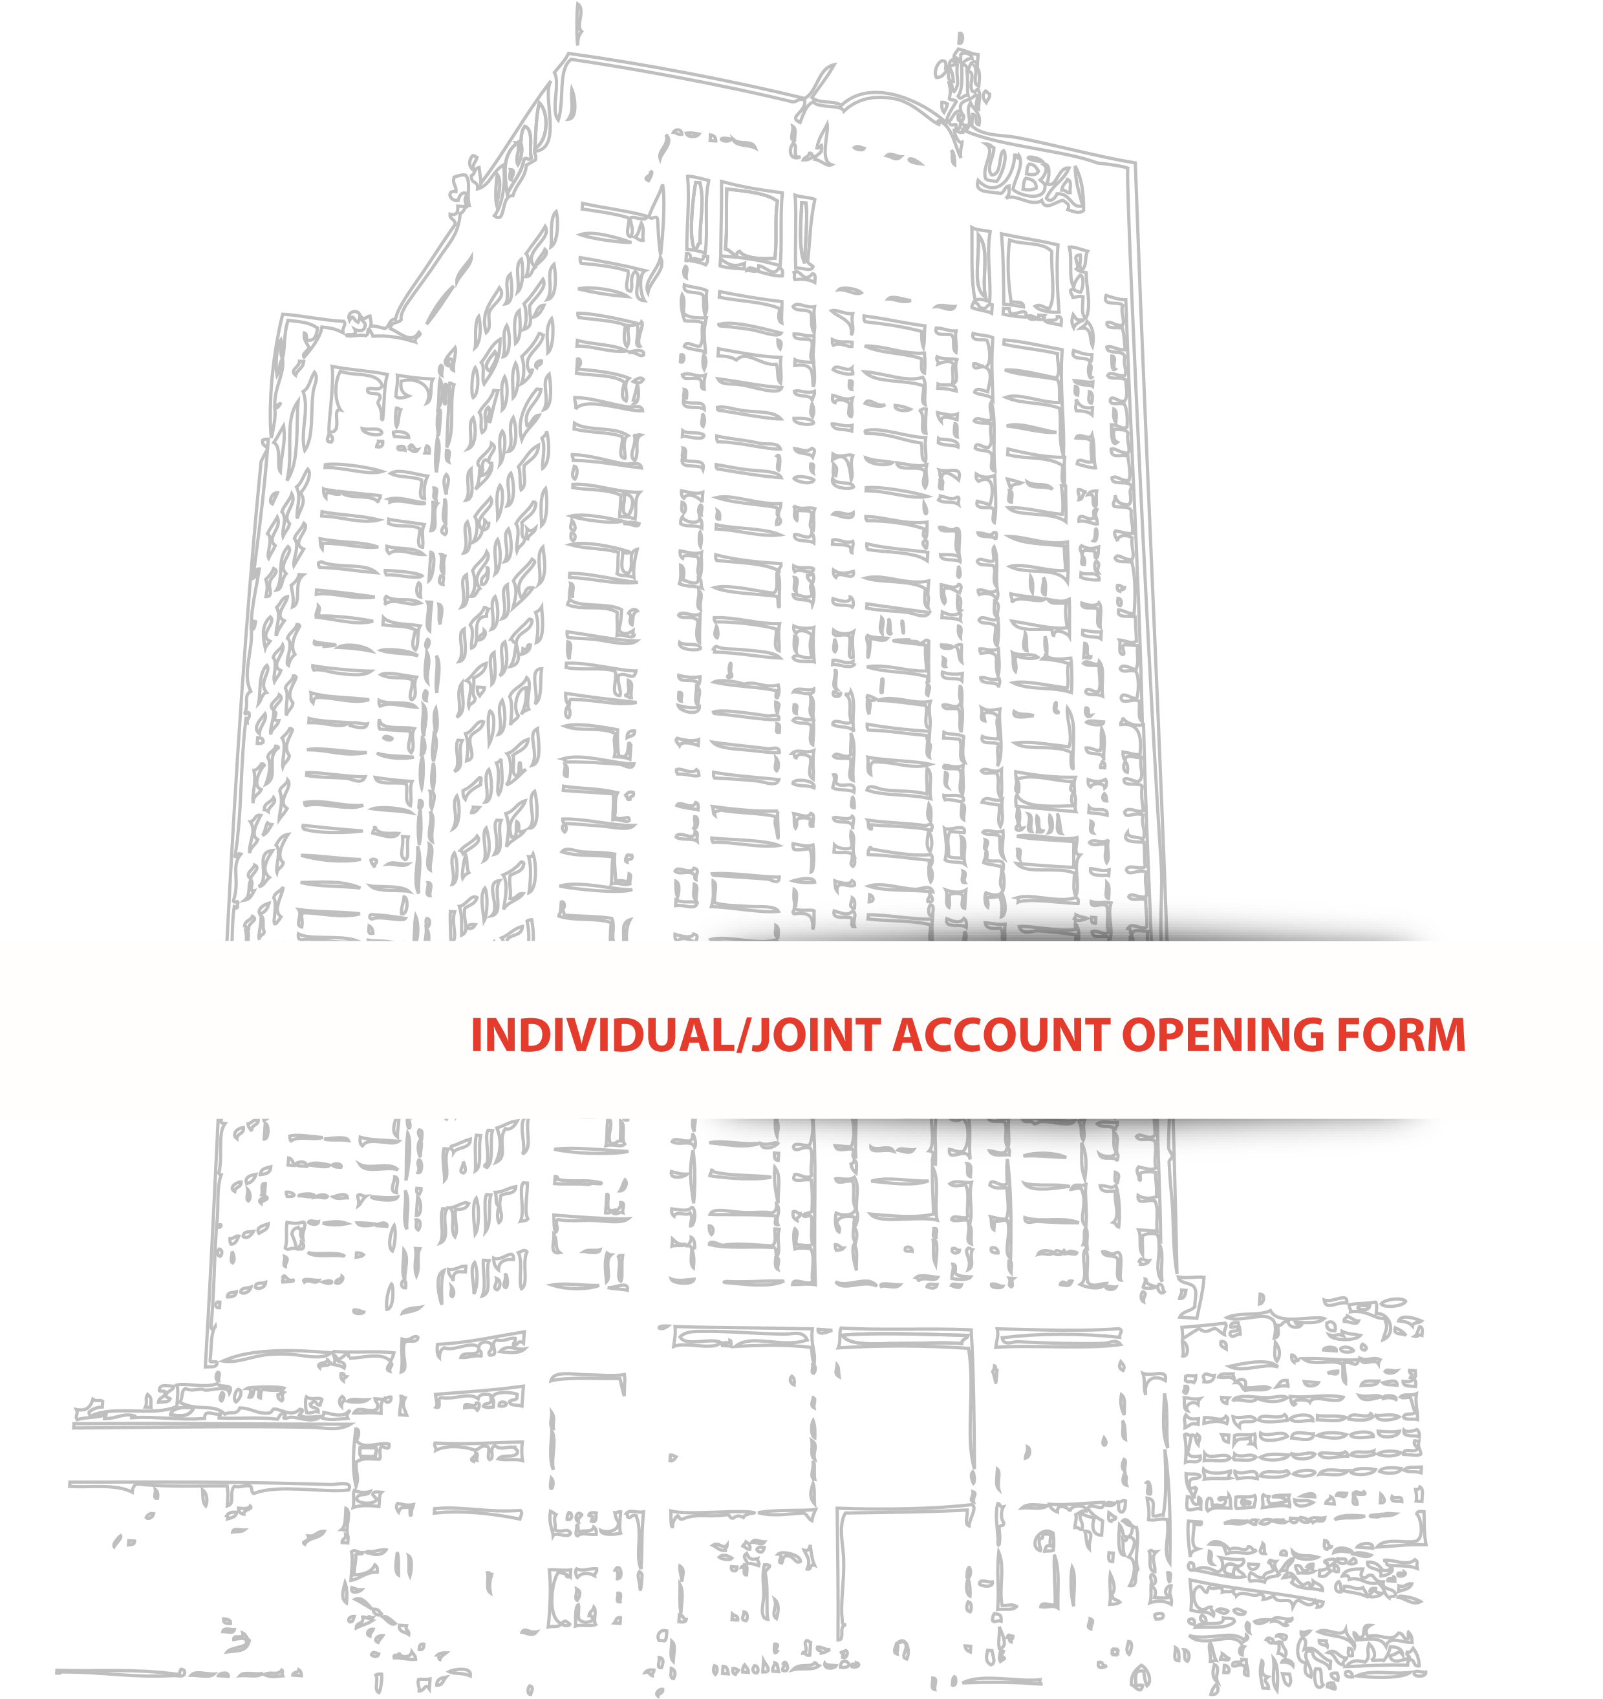

***Africa’s global bank***

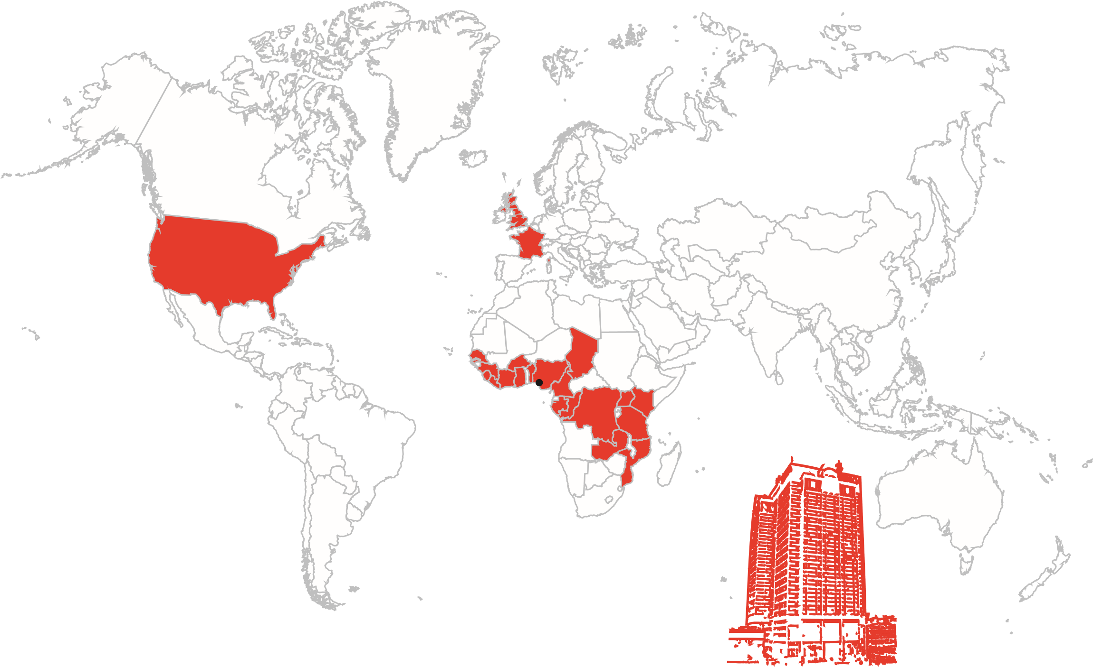

**HQ: Lagos, Nigera**

# Individual/Joint Account Opening Form

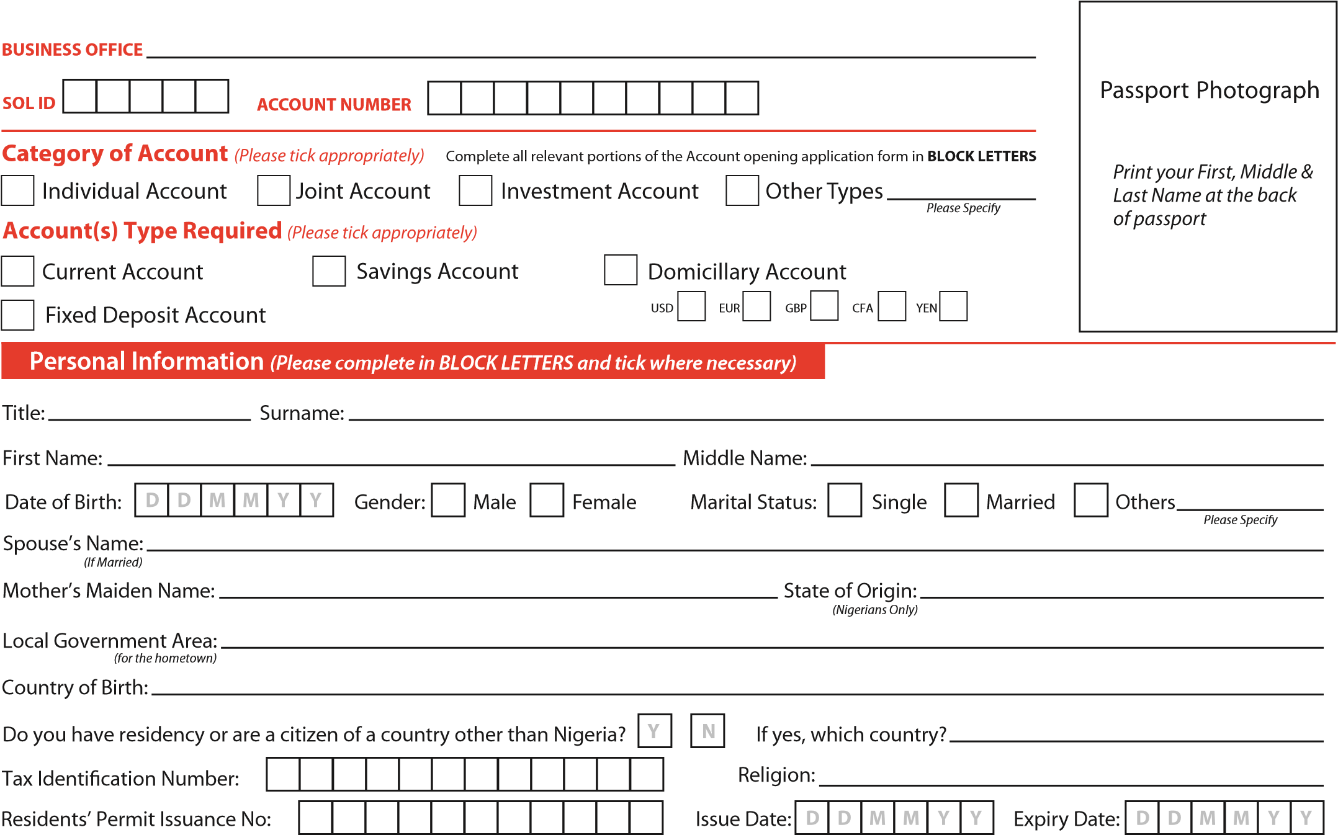

Purpose of Account: **Contact Details**

*Plot/House Number*

*Street Name*

Residential/Contact Address:

**UBA Debit Cards** *(Kindly indicate the type of card(s) being applied for)\**

|  |  |  |  |  |  |  |
| --- | --- | --- | --- | --- | --- | --- |
| **Visa Classic**  Can be used anywhere in the world  Requires Naira current/savings account  **Gold MasterCard (NGN)**  Can be used anywhere in the world | |  | | **Visa Dual Currency**  Can be used anywhere in the world  Requires US Dollar domiciliary account  **Gold MasterCard (USD)**  Can be used anywhere in the world  Requires US Dollar domiciliary account | |  | | **Verve**  Can only be used within Nigeria  Requires Naira current/savings account  **Gold MasterCard (GBP)**  Can be used anywhere in the world  Requires Pound Sterling domiciliary account | |  | | **Debit MasterCard**  Can be used anywhere in the world  Requires Naira current/savings account  **Gold MasterCard (EUR)**  Can be used anywhere in the world  Requires Euro domiciliary account |

* *Please note that both new and replacement cards attract a fee.*

Preferred Name on Card

|  |  |  |  |  |  |  |  |  |  |  |  |  |  |  |  |  |  |  |  |
| --- | --- | --- | --- | --- | --- | --- | --- | --- | --- | --- | --- | --- | --- | --- | --- | --- | --- | --- | --- |
|  |  |  |  |  |  |  |  |  |  |  |  |  |  |  |  |  |  |  |  |

* 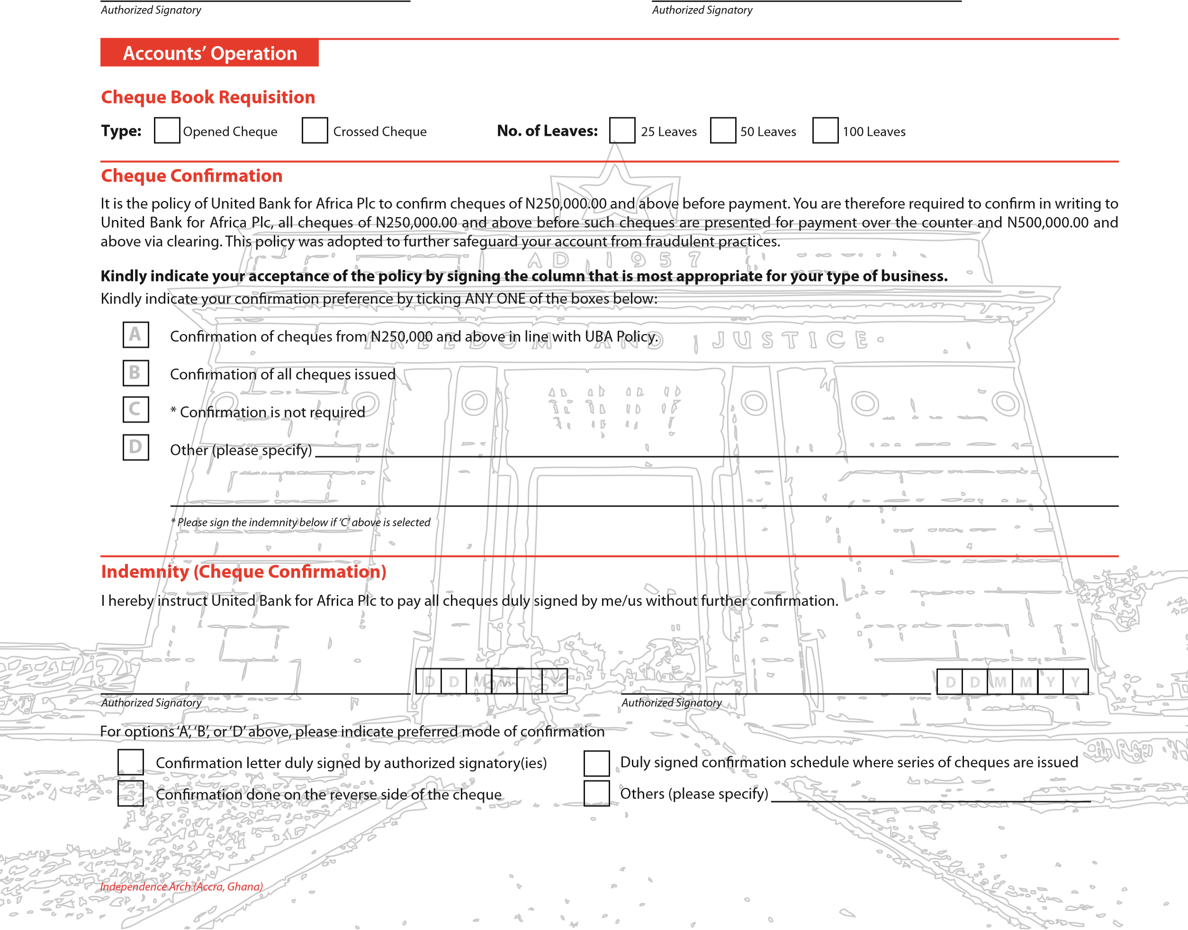*Maximum of 20 alphanumeric characters including spaces*

Email

Post

Collection at Branch

Monthly

Quarterly

Semi-Annually

Annually

**Statement Frequency**

**Account Statement Preferences**

Pay Manager

POS Services

Web Pay

Edu-Portal

Schools Online

U-Pay Connect

U-Pay

Pay Direct

Bank Collect

AutoReg

**Specialized Products’ Request**

*)*

*Please tick appropriately*

*(*

SMS Alert

Email Alert

**Transaction Alert Preferences**

**Charges:**

Enrolment for these services is

**FREE**

. Email Alert also comes

**FREE**

. Access charges and other applicable charges may be levied for funds

transfer and specific transactions. Please refer to the website

**https://www.ubadirect.com**

for further information.

**I/We hereby confirm that I have read and understood the Terms and Conditions (ref. Page 9) of the Electronic and Virtual Banking Services and I agree to be bound by same.**

|  |  |  |  |  |  |  |  |  |  |  |  |  |  |
| --- | --- | --- | --- | --- | --- | --- | --- | --- | --- | --- | --- | --- | --- |
| |  |  |  |  |  |  | | --- | --- | --- | --- | --- | --- | |  |  |  |  |  |  | | |  |  |  |  |  |  | | --- | --- | --- | --- | --- | --- | |  |  |  |  |  |  | |

## Employment Details

Employed Self Employed Unemployed Retired Student

Others

*Please Specify*

|  |  |  |  |  |  |
| --- | --- | --- | --- | --- | --- |
|  |  |  |  |  |  |

Date of Employment (if employed):

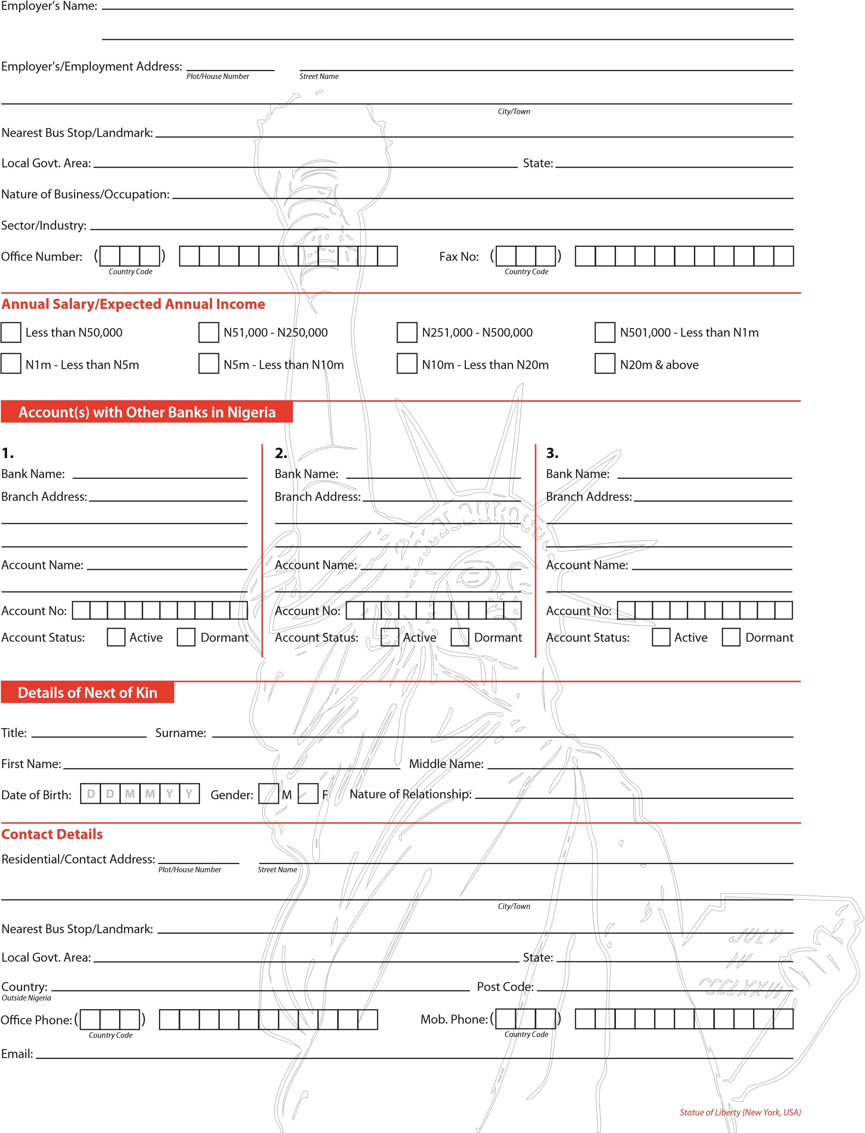

# Joint Account Additional Signatory Form

## Employment Details

Employed Self Employed Unemployed Retired Student

Others

*Please Specify*

|  |  |  |  |  |  |
| --- | --- | --- | --- | --- | --- |
|  |  |  |  |  |  |

Date of Employment (if employed):

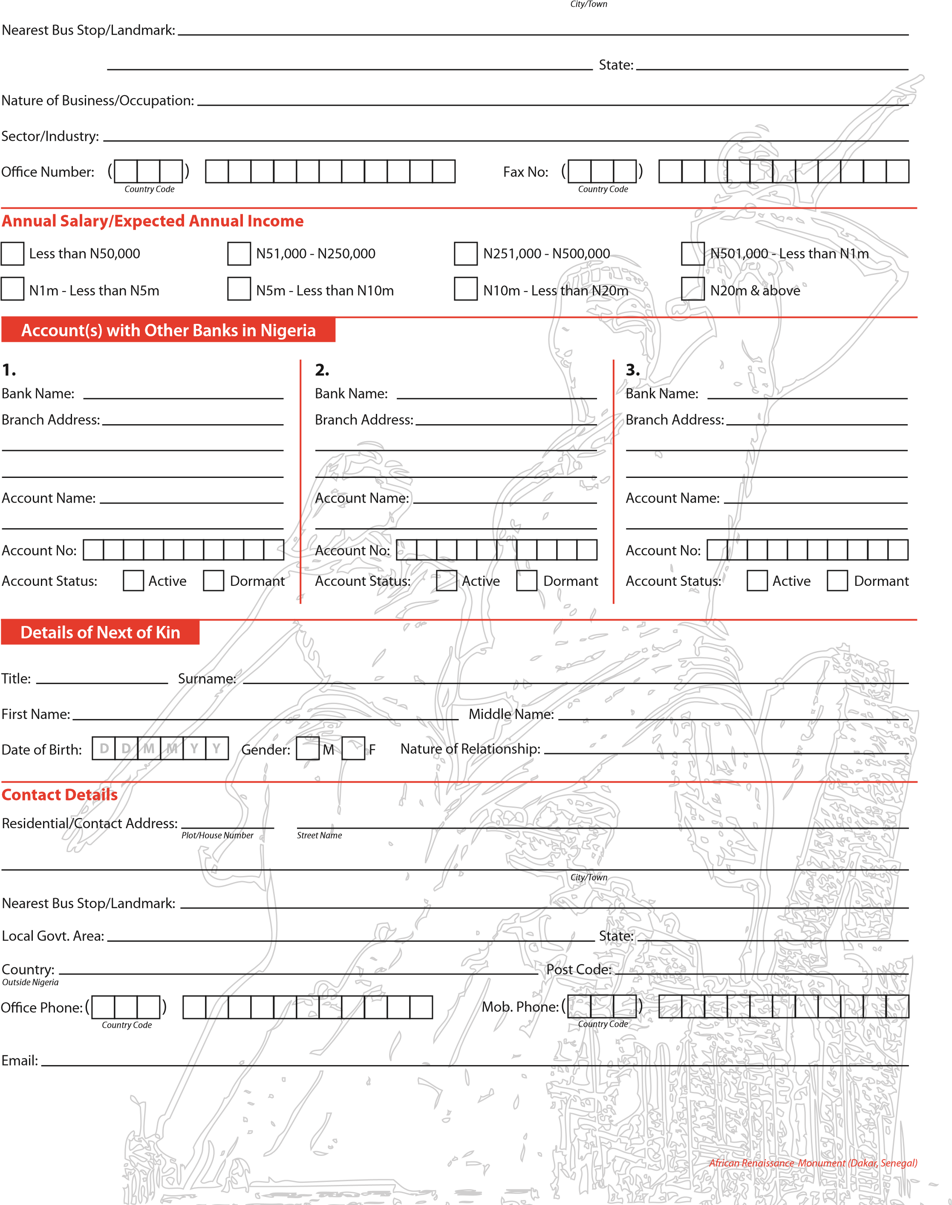Employer’s Name:

Employer’s/Employment Address:

*Plot/House Number*

*Street Name*

Local Govt. Area:

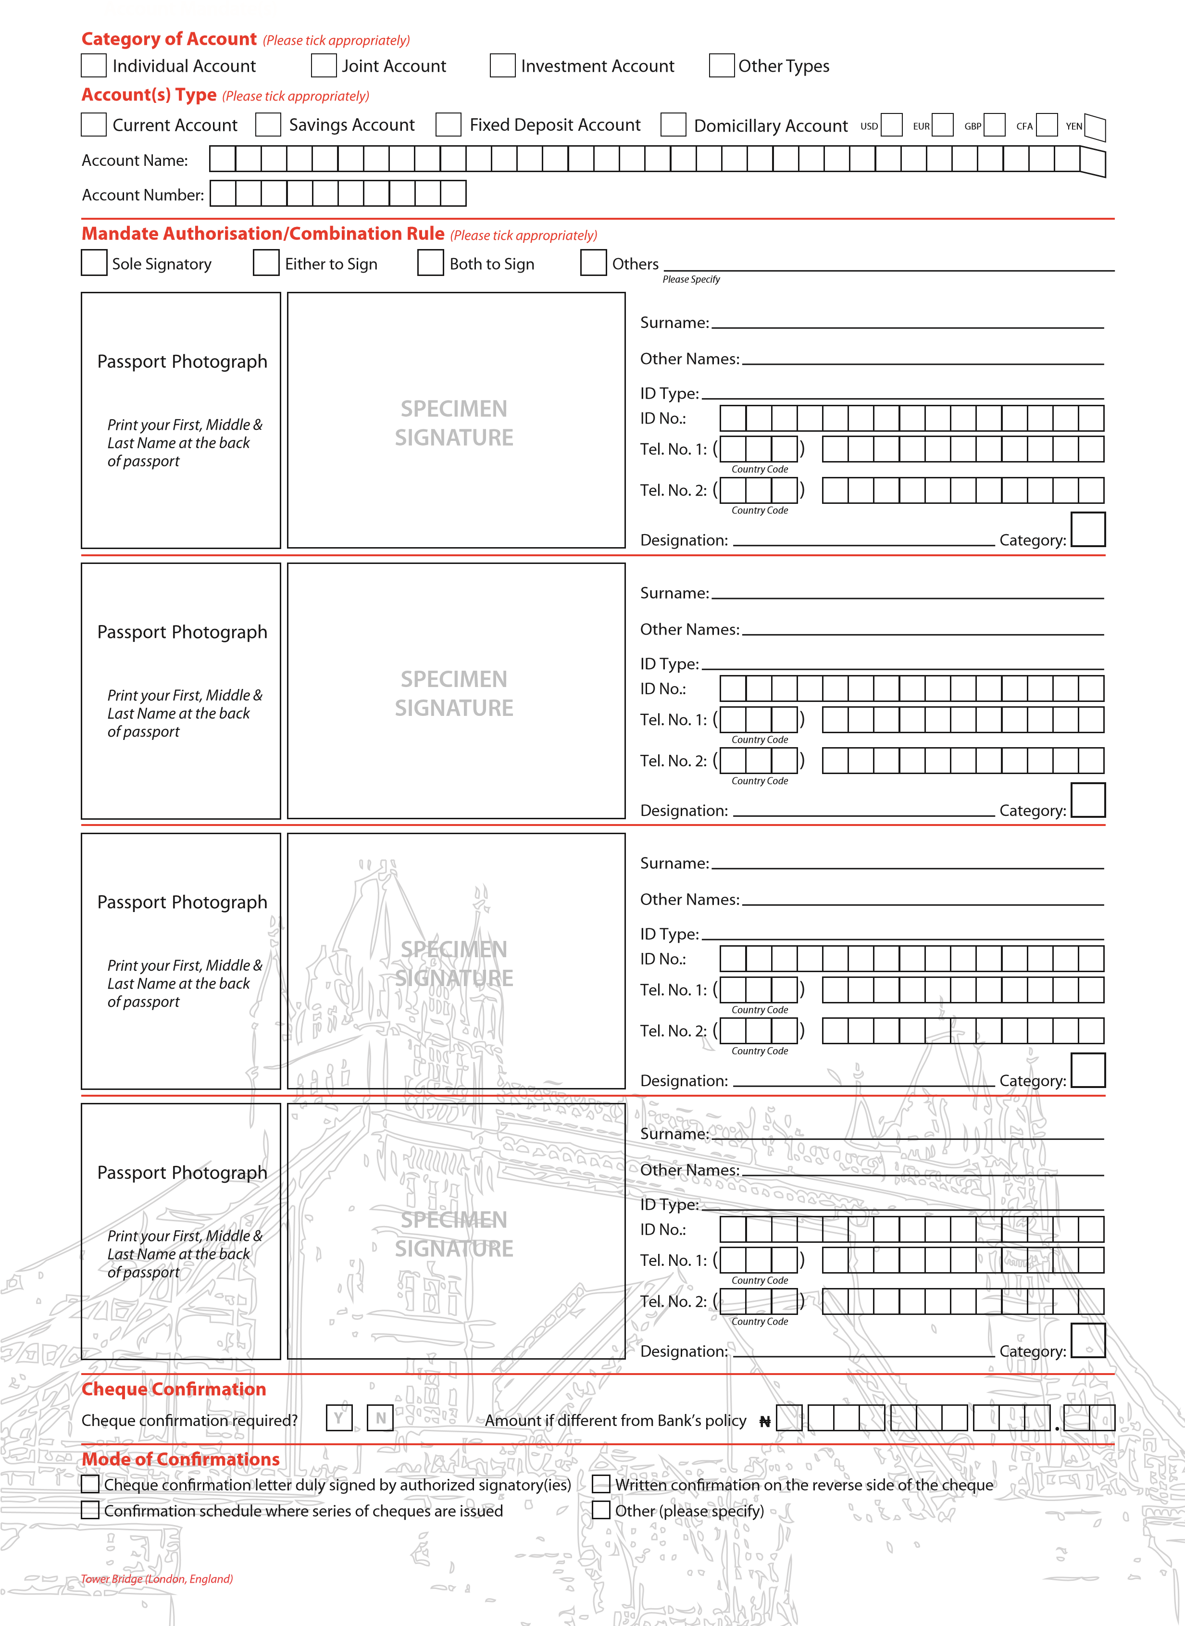

## Additional Details

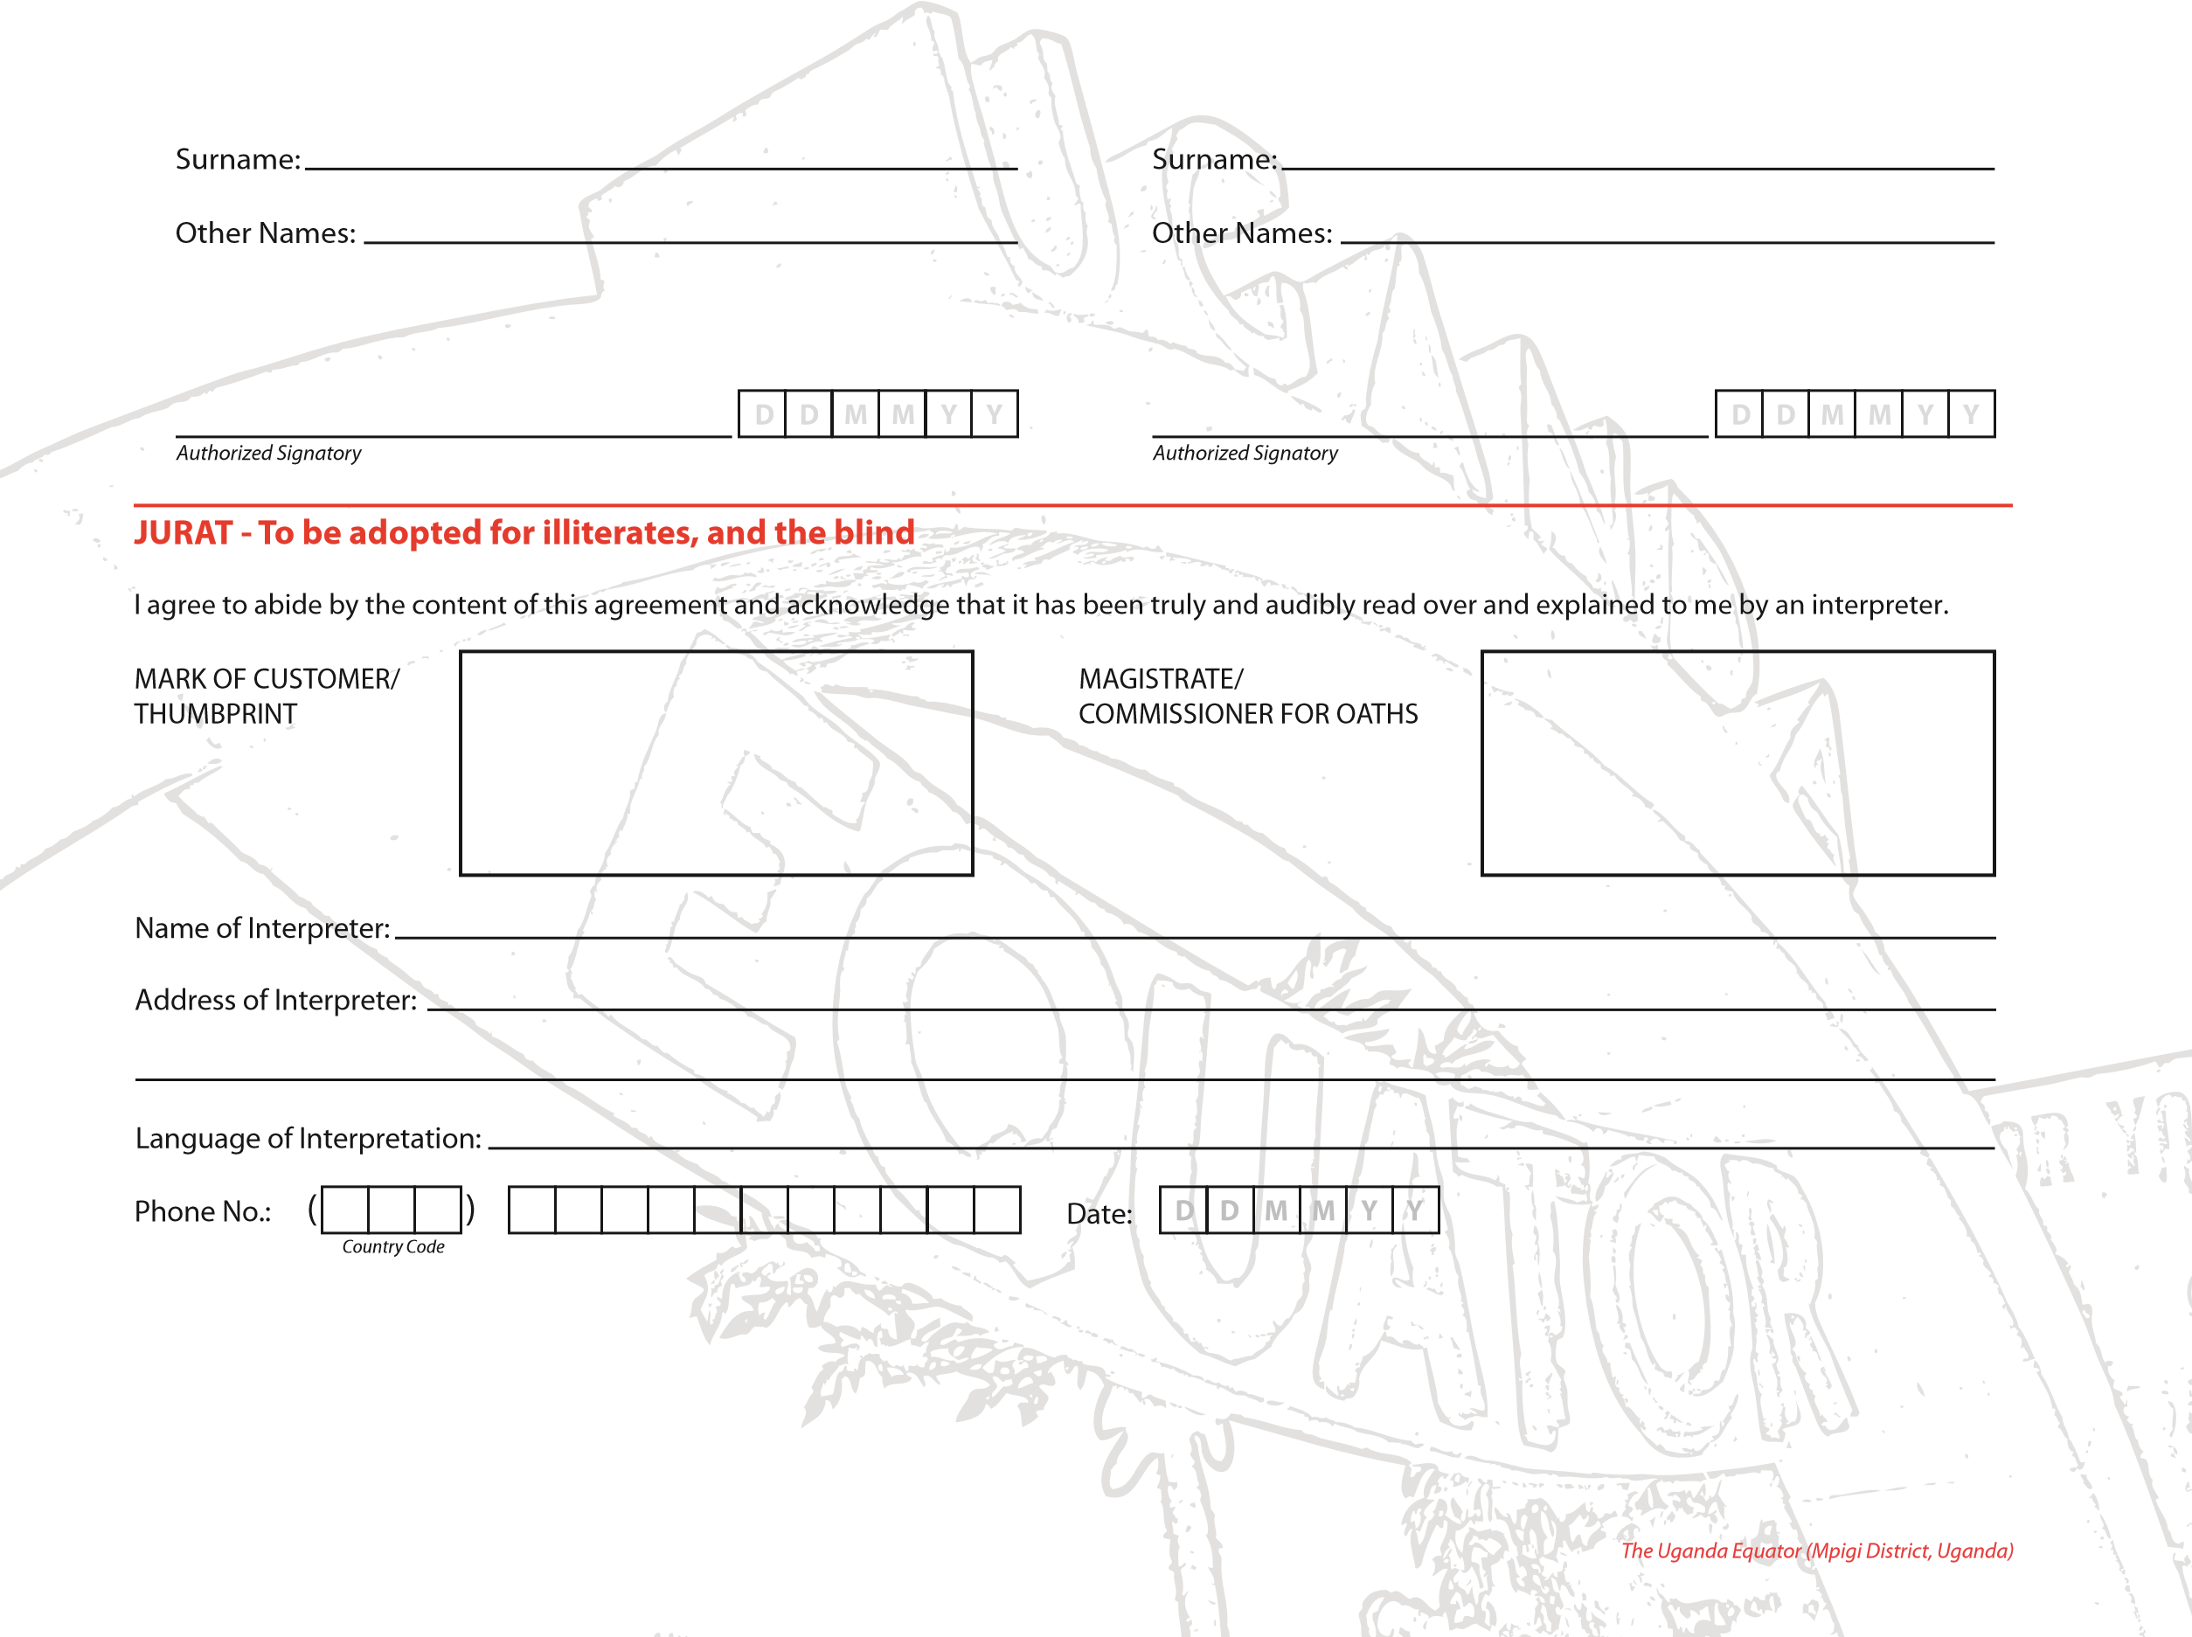Name of Beneficial Owner(s), if any:

Spouse’s Name (if applicable):

Spouse’s Occupation:

Name of Associated Business(es), if any:

**1**

**2**

Sources of Funds to the Accounts:

**1**

**2**

Expected Annual Income from Other Source(s):

*Other Source 2*

*Other Source 1*

**N**

**N**

**.**

**.**

Spouse’s Date of Birth:

**3**

Nature of Business:

**Declaration**

### CUSTOMER INFORMATION

I/We hereby apply for the opening of an account or accounts with Plc. I/We understand that the information given herein and the documents presented are the basis for opening such account(s) and hereby warrant that such information is correct. I/We further undertake to indemnify the Bank for any loss suffered as a result of any false information or error in the information provided to the Bank.

## GENERAL TERMS & CONDITIONS

These Terms and Conditions are applicable to all accounts whether opened on the date of signing these terms and conditions or on a later/prior date. The undersigned undertakes and agrees to be bound by these terms and conditions.

1. The bank will be entitled to debit the account(s) (where applicable) for any cheques, bills of exchange, promissory notes and orders for payment drawn, (where applicable) accepted or made by the authorised signatory(ies) and to carry out any instructions given by him/her/them or by attorney(s) duly authorised by him/her/them in connection with the account(s) mandate notwithstanding that any such debit or instructions carried out may cause such account(s) to be overdrawn or any overdraft to be increased, but always without prejudice to the bank's right to refuse to allow any overdraft or increase of overdraft.
2. The account holder(s) agree to be responsible for repayment of any such overdraft with interest accruing thereon together with any usual banking charges, interests and commissions.
3. The bank will be entitled to place to the credit of any account in account holder's name, including dividends, interest and capital funds arising from securities or proceeds of cheques or bills received or collected by the bank for the credit of the account holder.
4. In the event of the death of account holder, the next of kin is to advise the bank in writing of such death becoming known to him/her/them within ten (10) days thereof and in the absence of such written notice acknowledged by the bank, the bank is not liable for any claim on the bank arising from continuation of the account(s) and the bank shall not be held liable for allowing operations on the account(s).
5. The account holder is personally liable for any overdraft or the obligation arising in or in connection with the account(s) and the bank is hereby authorised to debit the account(s) with all interest commission and/or other banking charges and expenses (including legal charges) incurred in connection with the account(s).
6. It is further stipulated that all money's securities, bonds, collateral, shares, shipping documents, banknotes, gold or other valuables and properties of whatever nature which are held in the name of the account holder by the bank whether in any type of account or otherwise shall be so held as security to guarantee the settlement of any debit balance due to the bank arising under these general terms and conditions or any other credit or facility agreement granted or will be granted to the account holder in future. Furthermore, the account holder agrees to keep them within the bank's possession as “collateral against credit facilities” until the account holder fully pays his indebtedness to the bank including due interests, commission expenses and other due charges. If the account holder does not pay such indebtedness to the bank's first request, the account holder herewith authorises the bank to set off the outstanding balance from his/her possession held in “collateral against credit facilities” account without having to notify or inform him/her before hand. This authorisation is irrevocable and I/we cannot cancel it without the bank’s written consent. The bank shall have the right to always set off the balance in the account holder's accounts towards satisfaction of any of his/her liabilities to the bank or any other account or in any other respect whether such liabilities are present or future, actual or contingent, primary, several or joint. The debit balance of any one of my/our accounts will be secured by the credit balance of any other one of my accounts opened in any other foreign currency. The bank may debit any of account holder’s account opened at any of its Business Offices with the amount of any bills, guarantees, cheques and drawings, given, presented or purchased and signed by the account holder.
7. Any delay or omission of the bank in exercising or enforcing (whether wholly or in part) any right or remedy arising in respect of the account(s) shall not be construed as a waiver of such right or remedy.
8. The account holder agrees to maintain the minimum balance and all other conditions applicable to all accounts including Savings, Current and Domiciliary accounts. The bank may decide from time to time at its sole discretion without prior notice to the account holder to impose service charges on the account(s) if the minimum credit balance of such account(s) is/are less than the balance prescribed by the bank.
9. The bank will accept deposit of cheque(s) ~~f~~or opening of an account subject to KYC verification and satisfactory referen~~c~~e.
10. The account holder must immediately i~~nfo~~rm the bank in writing of any change in the details given on the account opening fo~~r~~m and any other changes thereto.
11. The bank will not be held liable ~~f~~or any ~~e~~xchange loss incurre~~d b~~y the account holder in converting/transferrin~~g~~ the balance from on~~e~~ curre~~n~~cy account to another currency account on the instructi~~o~~n o~~f~~ account holder.
12. Wh~~er~~e the ~~b~~ank has classified y~~o~~ur ~~a~~ccount or ac~~co~~unts as dormant, any funds remaining ~~i~~n the account or accounts will al~~w~~ays remain yo~~u~~r ~~p~~roperty (or if deceased, it will ~~f~~orm part of your es~~t~~at~~e u~~nless the accoun~~t (~~or a~~c~~c~~o~~unts) is a Joi~~nt~~ account, in whichcase it will pass to t~~he~~ survi~~v~~ing account hol~~d~~e~~r~~(s)). In~~te~~rest will continue to ~~b~~e paid where it applies ~~t~~o your acc~~o~~unt. You ~~m~~a~~y c~~ontact us at any time in relation to any funds i~~n~~ a do~~rman~~t account you believe to b~~e~~ yours and ~~w~~ewill r~~e~~instate your account or accounts (s~~u~~b~~je~~ct to c~~o~~nfirming your ide~~n~~tity ~~an~~d entitlement to the funds).
13. The ban~~k s~~hall h~~a~~ve t~~he ri~~ght at any time(~~s)~~ and at its absolute discretion by giving seven (7)days written notice to the account holder to c~~l~~o~~s~~ethe account and to request immediate ~~s~~ettlement thereo~~f~~ withou~~t~~ giving anyreason for ~~t~~aking such action, and wit~~h~~out incu~~rri~~ng any liabi~~l~~it~~y~~ w~~h~~at~~s~~oev~~e~~r to the account holder in so doing. The bank is ~~a~~lso entitled by gi~~v~~ing ~~w~~ritten notice to the account hold~~e~~r to close ~~th~~e ~~ac~~count:
14. If the balance thereof re~~m~~ains zero for ~~a~~ perio~~d~~ of thr~~ee~~ consecu~~t~~ive months;
15. If we re~~a~~sonab~~l~~y suspe~~c~~t that you hav~~e g~~i~~ve~~n us false informati~~o~~n,;
16. If we re~~a~~sonably suspect that your accountsi~~s~~ being used f~~o~~r ~~a~~n illeg~~a~~l purpo~~s~~e~~(~~s);
17. If you are using ~~a~~ personal accoun~~t~~ ~~f~~or purposesconnected ~~w~~i~~t~~h a business;
18. To comp~~ly~~ with Applic~~a~~ble law;
19. If youare in rep~~e~~ate~~d~~ br~~e~~ach of these ~~T~~ermsand Cond~~i~~tions; or
20. If ou~~r~~ a~~g~~ree~~m~~ent wi~~t~~h you is ~~t~~erminated or ~~c~~ancelled~~.~~

In the event of such clos~~u~~r~~e,~~ we will return any amount standing to your credit to your re~~g~~istered address or ~~i~~ssue bankd~~raft~~s ~~f~~or your pick~~-~~up at the branch of account domicile; after deduct~~i~~o~~n~~ of an~~y~~ tax, charges an~~d~~ fees(if ap~~pl~~ica~~ble~~).

If we d~~is~~cont~~i~~nu~~e~~ a product that yo~~u ha~~ve with us, wemay close your ~~a~~ccount b~~y giv~~ing ~~yo~~u 30 (thirty) days notice; a suitable ~~alte~~rnative account(if there is one) will be indicated to you, if ~~y~~o~~u~~ ~~d~~o not give us instructi~~o~~n~~s~~ t~~o~~ the contrary, we will transfer the fundsto thatac~~co~~untwhen we close your ac~~c~~ount.

Youmay close your acc~~o~~unt for any rea~~s~~onwithout ~~c~~harge and your existing credit balances shall be paid toyou provided t~~h~~at:

1. you inform us by giving 30 (thirty) days notice in wri~~t~~ing that you wish to clos~~e~~ your account;

*Former Masonic Lodge Palace (Monrov~~i~~a,Liber~~i~~a)*

1. you destroy all cheques;
2. you repay any money you owe the bank including the amount of any cheque, card transactions or other payment instructions you have made and any charges or interest incurred which we have not debited to your account;
3. the specific terms and conditions of your account permits you to do so.The account holder hereby agrees that the bank's action in closing the account shall be effective and binding upon him/her as from the date of the said notice for any reason whatsoever. The account holder hereby irrevocably waives in advance any right, whether legal or otherwise, that he/she may have against the bank in any proceedings whatsoever to complain about the bank's actions and/ or decision to close the account. 14. It is agreed that the bank shall have the right to modify the nature, conditions, and stipulations of these general terms and conditions by a simple written notice to the account holder or by notice posted in the banking hall including the rate of interest, commissions and other conditions to any account. Any such amendments shall be binding on the account holder from the date of the said notice that is from the date fixed by the bank in its absolute discretion even if the account holder has not received the said notice for any reason whatsoever.
4. The bank reserves the right to debit the account in case of erroneous credit made to the account holder’s account.
5. The account holder agrees to assume full responsibility for the genuineness, correctness and validity of all endorsements appearing on all cheques, orders, bills, notes, negotiable instruments and receipts or other documents deposited in his/her account.
6. The account holder agrees to hold the bank free from any responsibility for any loss of funds deposited with the bank due to any future Government order, law, levy, tax embargo, exchange restriction or any other cause beyond the bank's control.
7. The account holder agrees to accept as due notification any notice of change in conditions governing the account directed to the account holder’s last known address and to be bound by such change.
8. That if a cheque credited to my individual current account is returned dishonoured, the same may be transmitted to me through the last known address either by bearer or by post.
9. That my attention has been drawn to the necessity of safeguarding my cheque book, withdrawal booklet, ATM/Debit card, PIN etc so that unauthorized persons are unable to have access to it and to the fact that neglect of this precaution may be a ground for any consequential loss being charged to my account and I shall exempt the bank from any liability thereof. The account holder agrees to keep all security details on its accounts and online banking secret at all times.
10. If your UBA card expires or is reported as lost or stolen or subject to misuse, we may (at our discretion) provide you with a new UBA card.
11. The account holder agrees that unless there is an agreement with the bank in writing, only tellers sitting across the counter are authorised to handle cash and cheque transactions. I further agree that the bank will not be liable for any loss arising from cash and cheques given to unauthorized staff.
12. The account holder understands and agrees that the bank is under no obligation to honour any cheque(s) drawn on his/her account unless there are sufficient funds in the account to cover the value(s) of the cheques and account holder understands and agrees that such cheque(s) may be returned unpaid. The account holder understands further that the Issuance of dud cheques is a criminal offense under the Dishonoured Cheques (Offenses) Act of 2004 and that the bank is obliged to render reports to regulatory authorities on returned/dud cheques in accordance with banking laws and regulations as amended from time to time.
13. The account holder agrees that he/she will notify the bank of any disagreement with entries on his/her bank statements within fifteen (15) days of the dispatch of the bank Statement. Failing receipt by the bank of a notice of disagreement of entries within 15 days from the date of dispatch of his/her bank statement, it will be assumed by the bank that the statement as rendered is correct.
14. Withdrawals from any Domiciliary account sha~~l~~l be made only by the same mode of lodgement and in the currency of the account or in Naira at the request of the account holder in writing. And stamp, transmission or other charges related to withdrawals from the account will be paid in local currency by the undersigned upon demand or charged to the said acc~~o~~unt.
15. If you resid~~e~~ outside Nigeria and we have agreed that you can hold an account with us, you shou~~l~~d ensure that your having anaccount complies with any other applicable law or rules wh~~i~~ch ap~~p~~ly where you reside, including any tax, foreign exchange or capital controls and for all payments, reporting or filing requirements that may apply as a result o~~f~~ your count~~ry o~~f citizenship, domicile or residence. You agree to provide us with such inform~~at~~ion as we may ~~re~~asonably ~~re~~quire fr~~o~~m time to time, and most up-to-date information a~~s~~ reason~~a~~bly required fromtime ~~t~~o time, enabl~~i~~ng us or any of our subsid~~i~~aries comply withany applicabl~~e l~~aw.
16. Subject to applicable ~~l~~oc~~a~~llaws,acc~~o~~unt holder ~~her~~eb~~y~~ agrees that United bank for Africa Plc or ~~a~~ny of its subsidiaries and ~~a~~ffiliates (col~~l~~ectively “thebank”) can share his/her informati~~o~~n wit~~h~~ dome~~s~~tic or over~~s~~eas reg~~u~~l~~a~~tors orta~~x~~ au~~t~~horities where necessary to establish his/her tax liability in any ~~j~~urisdicti~~o~~n. Where required bydomestic or overseas re~~g~~ulators or tax authorities, theaccount h~~o~~lder agrees that the bank may withhold, and pay out, from my acco~~u~~nt(s) suc~~h~~ a~~m~~ounts as may be require~~d~~ accordi~~n~~g to applicable laws, regulations, agree~~m~~ents with regulat~~o~~rs or a~~u~~thorities and directives.
17. Where applicable, where an account hold~~e~~r does not providethe re~~q~~uisite document~~a~~tion in line ~~w~~ith the United States Foreign accou~~n~~tTaxC~~o~~mp~~l~~iance Act (FA~~T~~CA) requirements within 90 days fromth~~e~~ dat~~e~~ ofther~~e~~q~~ue~~st, ~~t~~heirf~~un~~ds will be subject to withholding.
18. The account holder agr~~ee~~s to comply with all ~~t~~erms andc~~o~~n~~d~~it~~i~~onsissu~~e~~d by the bank, governing the use of electron~~ic~~ banking s~~e~~rvi~~c~~es which ~~t~~he bank may from ti~~m~~e totime offer and provide to him/her, in order to ensure bankingc~~o~~nvenie~~n~~c~~e~~.
19. You mustcontact us immediately or at the latest within 30 ~~(~~thirty) day~~s~~ if ~~at~~ an~~y~~ time in the f~~u~~tu~~re~~ there is an important change to ~~th~~e information you have pre~~v~~io~~u~~sly ~~provi~~d~~e~~d ~~t~~o us, o~~r~~ if you ~~b~~ecome a US person~~.~~ If ~~yo~~u do ~~be~~c~~o~~me a ~~US~~ per~~s~~o~~n~~, you must complete and return to us as soon as reasona~~b~~l~~y~~ possibleanyr~~e~~levant U~~S~~ ~~ta~~x or w~~ai~~ver documen~~t~~ation that appl~~i~~es to you and that ~~w~~e may req~~u~~est f~~r~~om ~~ti~~me to time.
20. Exc~~e~~pt ~~w~~here the bank is ne~~g~~ligent or ~~f~~ra~~u~~dulent o~~r~~ in willful default, ~~w~~e shall ha~~v~~e no ~~r~~espons~~ib~~ility to you if anyinformation we h~~o~~ld abou~~t~~ you is ~~o~~r ~~b~~e~~c~~o~~m~~es inaccurate or incomplete.

## ELECTRONIC BANKING TERMS & CONDITIONS

I/We (“Customer”) confirm and agree that the following terms and conditions shall govern my/our electronic banking transactions with the bank.

"Service" means the Electronic Banking Services of United Bank for Africa Plc (”the Bank”), including ATM Transactions, Internet Banking, Telephone Banking, Secure Message Facility and Bills’ Payment services.

"User name and Password" means the enabling code with which you access the system and which is known to you only.

“Account" means a current or savings account or other account(s) maintained with the bank at any of the bank's branches in Nigeria and other country(ies).

“PIN" means your personal identification number.

"Mailing Address" means the customer's mailing address in the bank's records as updated from time to time.

"Instruction" means the customer's request to the bank for the services.

"ATM" means Automated Teller Machine that dispenses cash to or receives cash/cheque from account holders with the use of a debit card or credit card.

"ATM Card" means the card used by a customer for processing transactions through Automated Teller Machine.

"Secure Message Facility" means the facility within the e-Banking Service that enables the Client to send electronic messages (e-mail, SMS) to the Bank, including without limitation free-format messages, fixed format messages, or instructions to make payments, requests for cheque books, banker's drafts or the purchase or sale of securities and interest in mutual fund.

1. The service allows the customers to give the bank instructions by use of:

(a) ATM, PIN, Password, User name and secure message (email, SMS) for the following:

1. Obtain information regarding customer's balance as at the last date of business with the bank;
2. Obtain information with regards to any instrument in clearing or any credit standing in the customer’s account as at the last date of transaction on the customer's account; (iii)Authorize the Bank to debit the customer's account to pay a specified utility bill such as NITEL, NEPA, WATER RATE and/or any other bills as specified by the customer subject however to availability of such bill payment under this service;
3. Authorizing the bank to effect a transfer of funds from the customer's account to any other account with the bank;
4. Authorizing the bank to effect any stop payment order;
5. Authorizing the bank to debit customer’s account and load same into any form of prepaid card.
6. On receipt of instructions, the bank will endeavor to carry out the instructions promptly, except in situations of unforeseen circumstances such as act of God, force majeure, system failure and other causes beyond the Bank's control.
7. For the service to be available to any customer, he/she must have a combination of the following:
8. An account with the Bank;
9. a username and password;
10. a Personal Identification Number "PIN"; and(iv) an E-mail address.

4. Under no circumstances shall the customer allow anybody access to his/her account through the service. 5. The Password/e-mail

(a) The customer understands that his/her password/e-mail is to be used to give instructions to the bank and accordingly undertakes:

1. That under no circumstance shall the password be disclosed to or assessed by any body;
2. Not to wri~~t~~e ~~th~~e password to avoid third party coming across same.
3. The customer instr~~uc~~ts and authorizes the bank to comply with any instructions given to the ban through the us~~e~~ of the service.
4. Once the bank is instructed by means of the customer's PIN the bank is entitled to assume that thos~~e~~ are the instructions given by the customer and to rely on same.
5. The customer'spassword, acce~~s~~s codes must be changed immediately it becomes known to someone else.
6. The bank is exempted from any form of liability whatsoever for complying ~~w~~ith any or all instruction(s) given by means of the customer's password/PIN if by any means the password/PIN, becomes known to a third party or otherwis~~e~~ becomes compromised.
7. Where a customer notifies the bank through e-m~~a~~i~~l~~ of his/her intention to change his password/PIN arising from l~~o~~ss of memory of same, or that it has come to the notice ~~o~~f a third party, the bank shall, with the consent of the customer, delete same ~~an~~d ~~t~~h~~e~~reafter allow ~~t~~he customer to enter a new password/PIN provided that ~~t~~h~~e~~ bank shall ~~n~~ot ~~b~~e responsi~~b~~le for any loss that occurs between the periodof such lo~~s~~s ofmemory of the
8. User acknowledges that the alert and other information sent to him or accessed by him contain confidential information and should such information be sent to a third party through no fault of UBA Plc, UBA shall not be held liable.
9. UBA will not be liable for non-delivery or delayed delivery of alerts, emails, errors or losses or distortion in transmission of alerts and emails to the USER. UBA shall not be liable for lack of receipt of alerts due to technical defects on customer's phone or computer or any damage or loss incurred by the USER as a result of causes not directly attributable to UBA.
10. UBA shall not be liable to the us~~er~~, or to any third party for any drawing, transfer, remittance, disclosure, or any activity, or incidence on the user's account, whether authorized by the user or not, PROVIDED that such drawing,

password/PIN or knowledge of a third party and the time the report is lodged with the bank.

1. Once a customer's password/PIN is given, it shall be sufficient confirmation of the authenticity of the instruction given.
2. The customer shall be responsible for any instruction given by means of the customer's password/PIN. Accordingly, the bank shall not be responsible for any fraudulent, uplicate or erroneous instructions given by means of the customer's password/PIN.
3. Where an ATM card is issued to a customer, the card shall remain the property of the Bank at all times. The bank may, at its sole discretion, cancel the ATM card and request its return at any time, in which case the cardholder shall immediately comply with such request.
4. The ATM card is issued entirely at the risk of the customer who shall indemnify the bank for all loss or damage howsoever caused resulting from the use of the card. The cardholder shall take every possible care to prevent the card from being lost, mislaid or stolen and the cardholder undertakes not to pass the card to any other person.
5. The ATM card holder shall notify the bank immediately if the ATM card is lost, mislaid or stolen or if it comes into the hands of a third party or if the PIN is unwittingly or otherwise is disclosed or made available to a third party, in all circumstances. The bank will not be liable for any damages or loss resulting from loss of the card. Where oral notice of loss or theft is given, it must be confirmed in writing to the cardholder's branch of the bank within 48 hours of the receipt of notice.
6. The bank shall debit the ATM card holder's account with the amount of any withdrawal/transfer payment of telephone, water, electricity bills/payment for goods and services at point of sales (POS) terminals and all such payments as effected by the use of the ATM card along with the related bank charges.
7. The bank reserves the right to limit the total cash sum withdrawn by the ATM cardholder and total amount spent on POS terminals during any 24 hour period. The bank shall not be responsible for any loss or damage arising directly or indirectly from any malfunction or failure of the ATM card or the ATM or the temporary insufficiency of funds in such machine. 11. Customer's Responsibility
8. The customer undertakes to be absolutely responsible for safeguarding his username, password, PIN, and under no circumstance shall the customer disclose any or all of these to any person;
9. The customer undertakes to ensure the secrecy of his password/PIN and password by not reproducing same in any manner whatsoever either in writing or otherwise capable of making it known to persons other than the customer;
10. The bank is expressly exempted from any liability arising from unauthorized access to the customer's account and/or data as contained in the bank's records via the service, which arises as a result of inability and/or otherwise of the customer to safeguard his PIN, password and/or failure to log out of the system completely by allowing on screen display of his account information;
11. The bank is further relieved of any liability as regards breach of duty of secrecy arising out of customer's inability to scrupulously observe and implement the provisions of clauses;
12. The customers access code and password must be changed immediately it becomes known to anyone else and therefore the customer is under a duty to notify the bank by contacting the Customer Interaction Centre by telephone and in writing whenever his/her access code and/or password is suspected to be or has become known to another person;
13. The customer shall be responsible for any fraud, loss and/or liability to the bank or third party arising from usage of the customer's access code, password, PIN and/or password by both a third party and other unauthorized access. Accordingly the Bank shall not be responsible for any fraud that arises from usage of the customer's access code, password, PIN and/or password;

(vii)The customer undertakes to ensure that his/her PIN is not one that can be easily guessed by anyone including but not limited to addresses, telephone numbers, anniversaries, birthdays, simple sequence numbers etc.

1. Upon enrolling a customer for the service, the customer may be chargedthe applicable monthly fee and/or usage fee whether or not the customer mak~~e~~s use of the service during the period in question.
2. 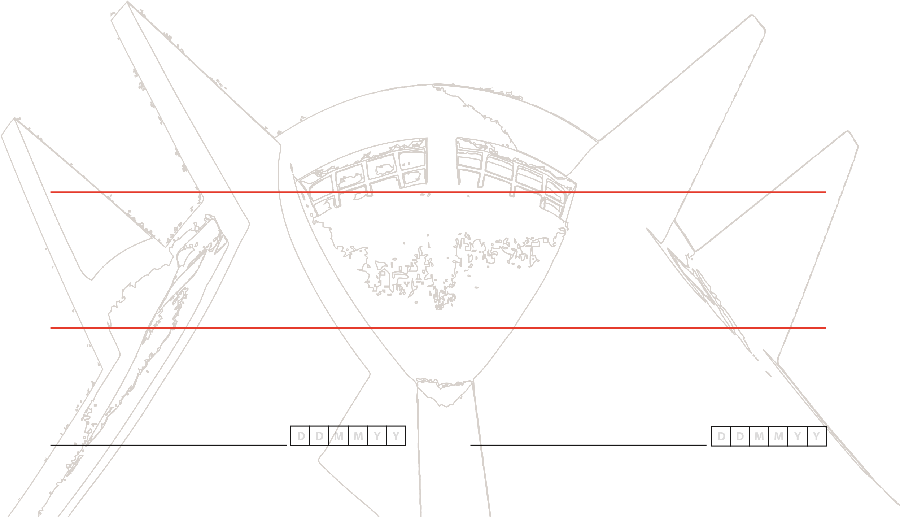Under no circumstances will the bank be liable fo~~r~~ any damages,including without lim~~i~~tation direct or indirect, special, incidental or consequential damages, losses or expenses ar~~i~~sing in connection with this service ~~o~~r use thereof or inability to use by any party, or in conne~~ct~~ion with any failure of performance, error, omission, interruption, defect, d~~e~~lay in operation, transmission, co~~m~~puter virus or line or s~~y~~stem failure, even if the bank or its representatives thereof are ~~ad~~vised of the possibility of such damages, losses or hyperlink to other internet resources are at the customer's risk.
3. ~~Copy~~right in the pages and in the screens displaying the pages, and in the informati~~o~~n and ma~~t~~erial therein ~~a~~nd arrangement is owned by the bank.

transfer, remittance, disclosure~~,~~ orany activity, or incidence was user authorized or made possible by the fact of

the knowledge and/ or use, or m~~a~~nipulation of the user's password, or otherwise by the user's negligence. User *The Nabemba Tower (Brazzaville, Republic of Congo)* acknowledges that his password shall be known only to him and kept secret at al~~l~~ times.

1. In the even~~t~~ ~~of~~ loss or theft of the phone or compromise of the security of the provided email account, the user shall c~~a~~ll CFC hotlines: 01-2808-822, 01-6319-822, 0700-2255-822 or email CFC@ubagroup.com and immediately notifythe Bank in writing within 24 hours of the loss/theft of ~~p~~hone or computer and email/password compromise.
2. ~~U~~BA in its absolute discretion and without prior notice can temporary suspend this, any or all of the service or terminate them completely.

I/We h~~e~~reby confirm that I/we have read and understood the above terms and conditions of the Virtual Banking Service and General Terms and Conditions and I/we agree to be bound by same.

*Authoriz~~e~~d Signatory Authorized Signatory*

*Monument Aux Heros Nationaux (Ouagadougou, Burkina Faso)*

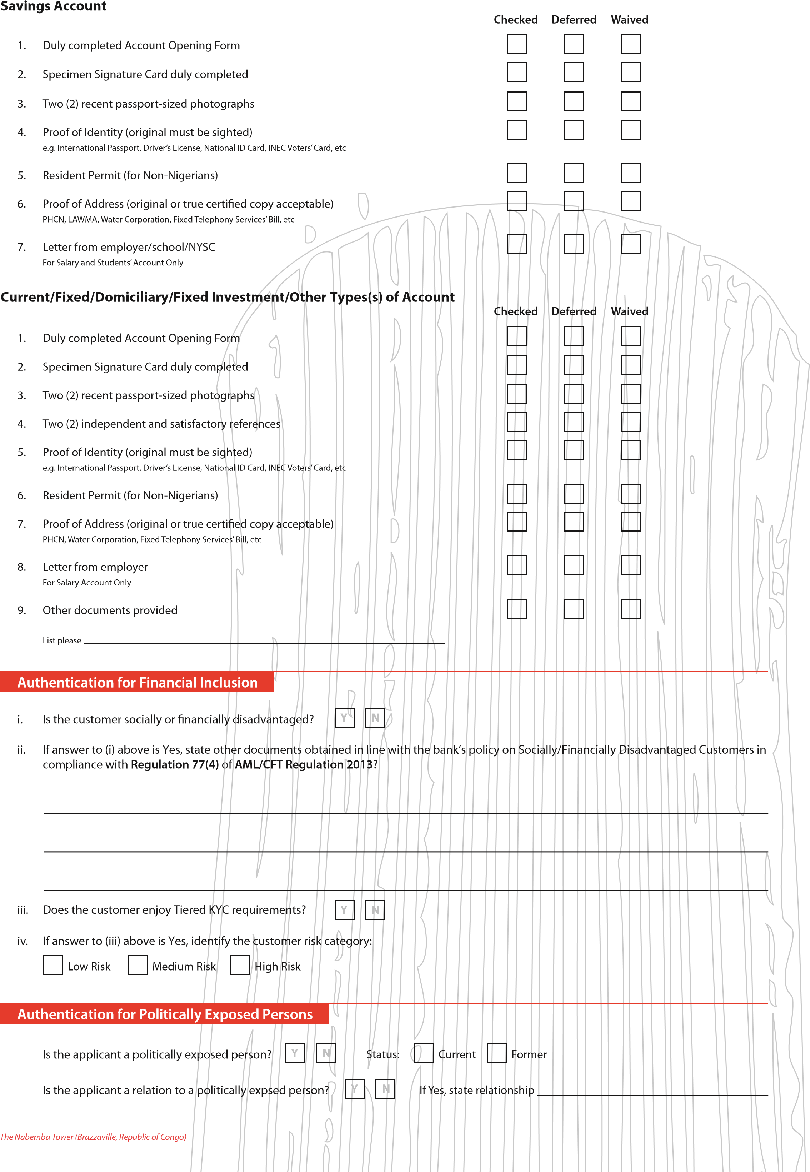**FOR BANK USE ONLY**

**Requirements’ Checklist**

**FOR BANK USE ONLY**

## Account Opened By

Staff ID:Staff ID:

Surname:Surname:

|  |  |  |  |  |  |
| --- | --- | --- | --- | --- | --- |
|  |  |  |  |  |  |

|  |  |  |  |  |  |
| --- | --- | --- | --- | --- | --- |
|  |  |  |  |  |  |

Other Names: Other Names:

*Signature*

*Signature*

**Address Verification Carried Out By**

Other Names:

Surname:

Staff ID:

Other Name

~~s~~

:

Surname:

Staff ID:

|  |  |  |  |  |  |  |  |  |  |  |  |  |  |
| --- | --- | --- | --- | --- | --- | --- | --- | --- | --- | --- | --- | --- | --- |
| |  |  |  |  |  |  | | --- | --- | --- | --- | --- | --- | |  |  |  |  |  |  | | |  |  |  |  |  |  | | --- | --- | --- | --- | --- | --- | |  |  |  |  |  |  | |

*Signature*

*Signature*

**Deferral/Waiver of Documents (if any) Authorized By**

Other Names:

Surname:

Staff ID:

Other Names:

Surname:

Staff ID:

|  |  |  |  |  |  |  |  |  |  |  |  |  |  |
| --- | --- | --- | --- | --- | --- | --- | --- | --- | --- | --- | --- | --- | --- |
| |  |  |  |  |  |  | | --- | --- | --- | --- | --- | --- | |  |  |  |  |  |  | | |  |  |  |  |  |  | | --- | --- | --- | --- | --- | --- | |  |  |  |  |  |  | |



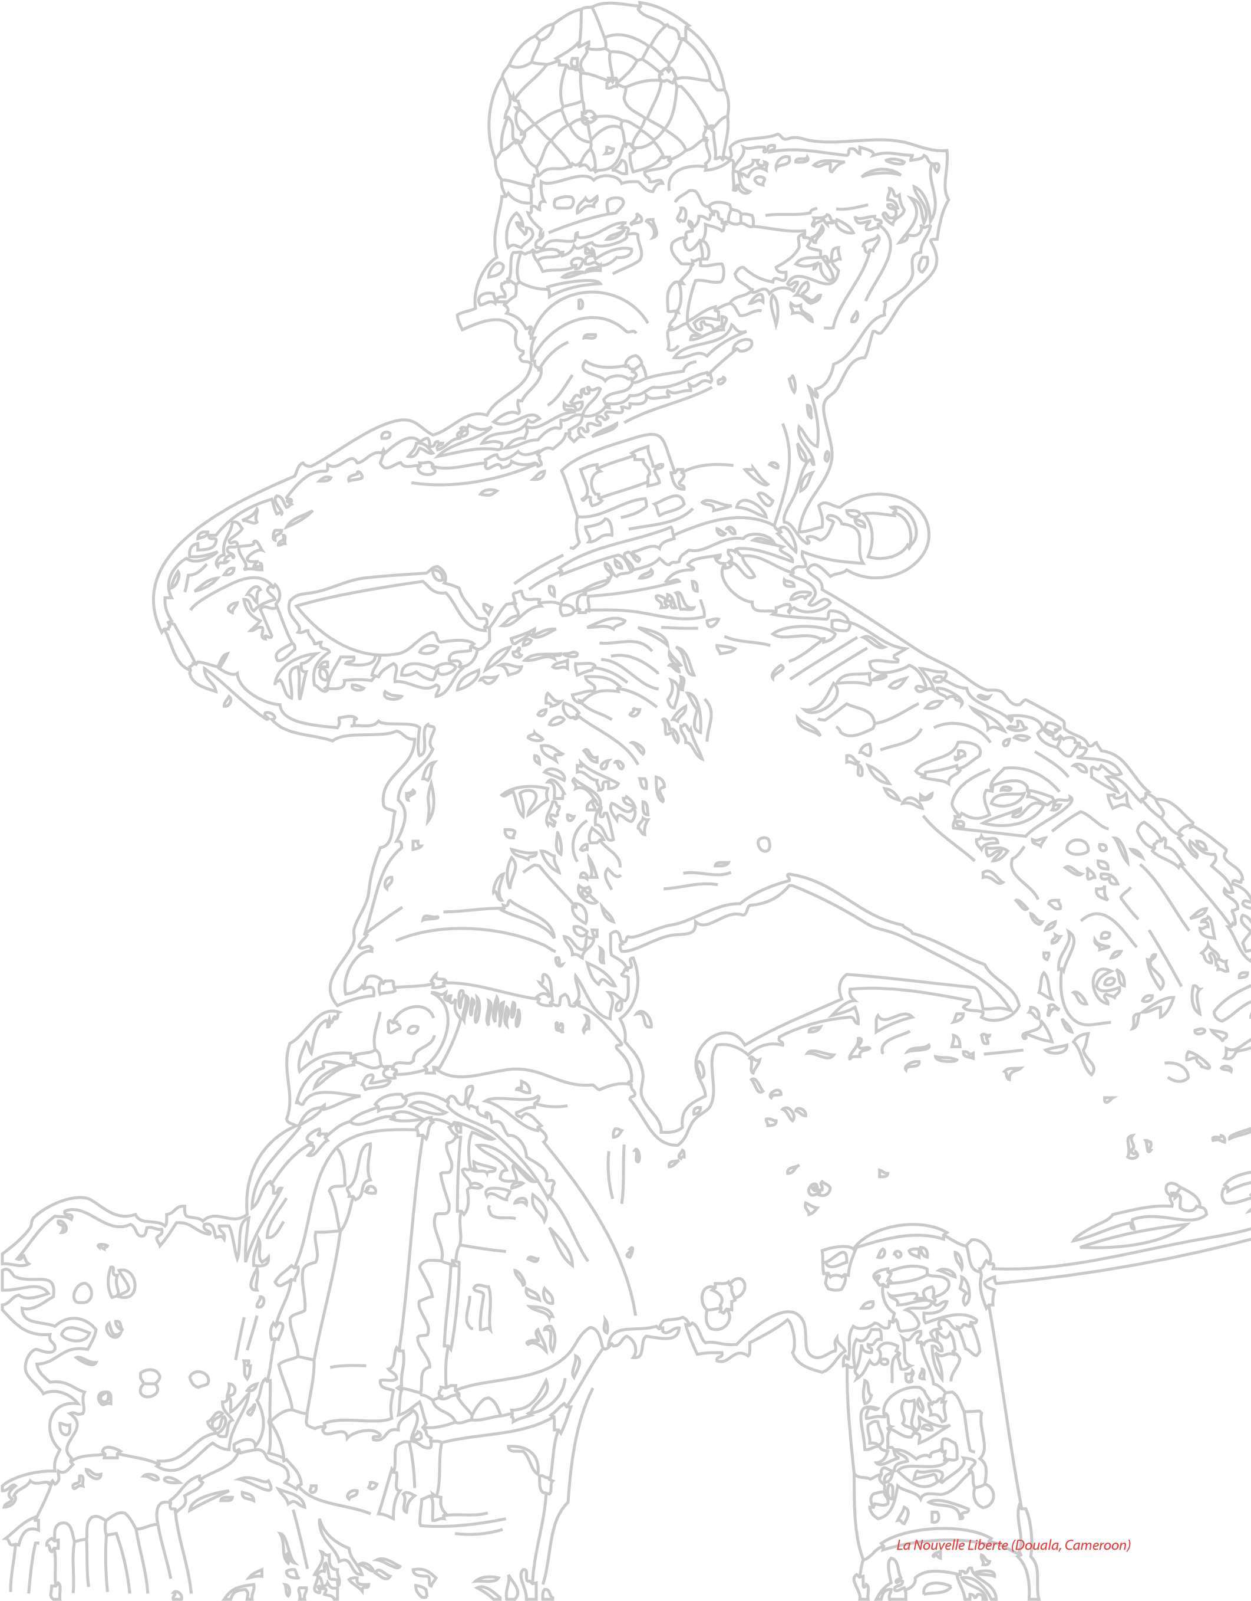

Africa

London

New York

Paris

www.ubagroup.com